ENGINEERING OF PHYSICS
MECHANICAL PHYSICS LABORATORY II
EXPERIMENT NAME: OHM’S LAW- SERIES AND PARALLEL CIRCUITS
EXPERIMENT NO: 2
STUDENT NAME SURNAME:
STUDENT NUMBER:
DEPARTMENT&EDUCATION TYPE:

PART 1: SERIES CIRCUIT
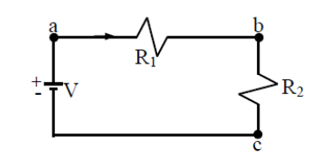

V= 5.05 V (applied voltage)
R₁= 11Ω V₁= 0.95 V (measured voltage)
R₂= 47Ω V₂= 4.14 V (measured voltage)
Calculate the current I for this circuit. And after calculating current, check the voltages across each resistor. Find the percentage error of the voltages V₁ and V₂.

